Dear {Name},
I hope this email finds you well,
My name is Marcus from ALT Logistics Vietnam. Please find our latest ocean freight rates from HCM / HPH / VUT to Europe, valid until 17 July, for your kind reference.
If you have any inquiries or shipment opportunities, please feel free to let me know. We will do our best to provide competitive rates and support your business.
In addition, please find our refund policy for CIF shipments to Vietnam below:
- Air freight: USD 20 per bill
- Sea freight: USD 15 per container (minimum USD 20 per bill)
- LCL: USD 5 per CBM
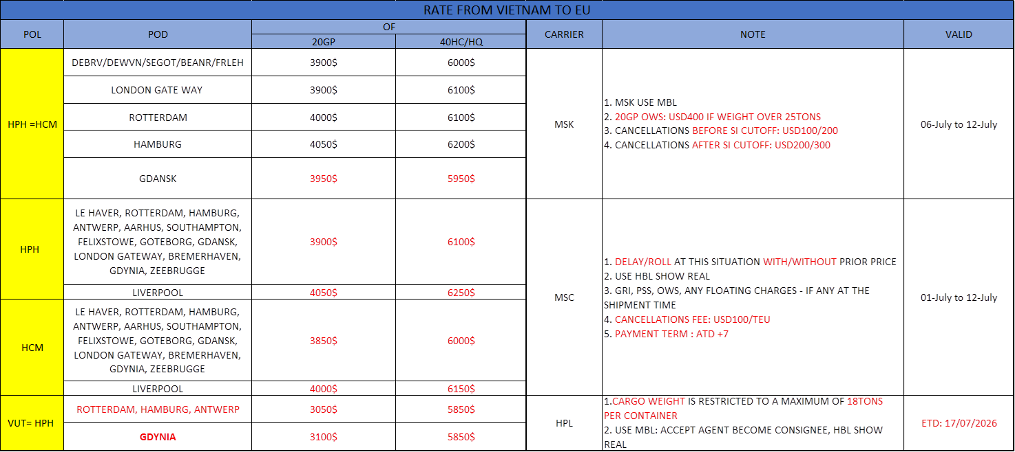

Thanks and Best Regards  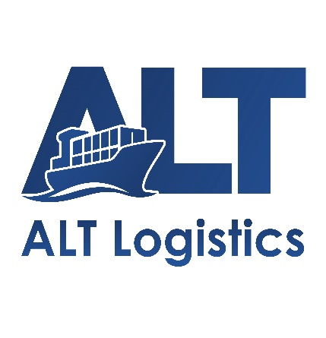 | Mr Marcus Nguyen  Overseas Agent Department  AN LOC THINH LOGISTICS JOINT STOCK COMPANY –  ALT LOGISTICS JSC  Ha Noi/Ho Chi Minh/Hai Phong offices  Head Office: 4th Floor, UP Office Building, No. 15/259 Yen Hoa Street, Yen Hoa Ward, Hanoi, Vietnam  Website: https://altlog.vn/  Email: Marcus@altlog.vn  WhatsApp/ Zalo: (+84) 398998159 Wechat: marcus_nguyen_altlog  Mobile: (+84) 398998159 Tel: (+84) 24 62810994


